AudioViz Documentation
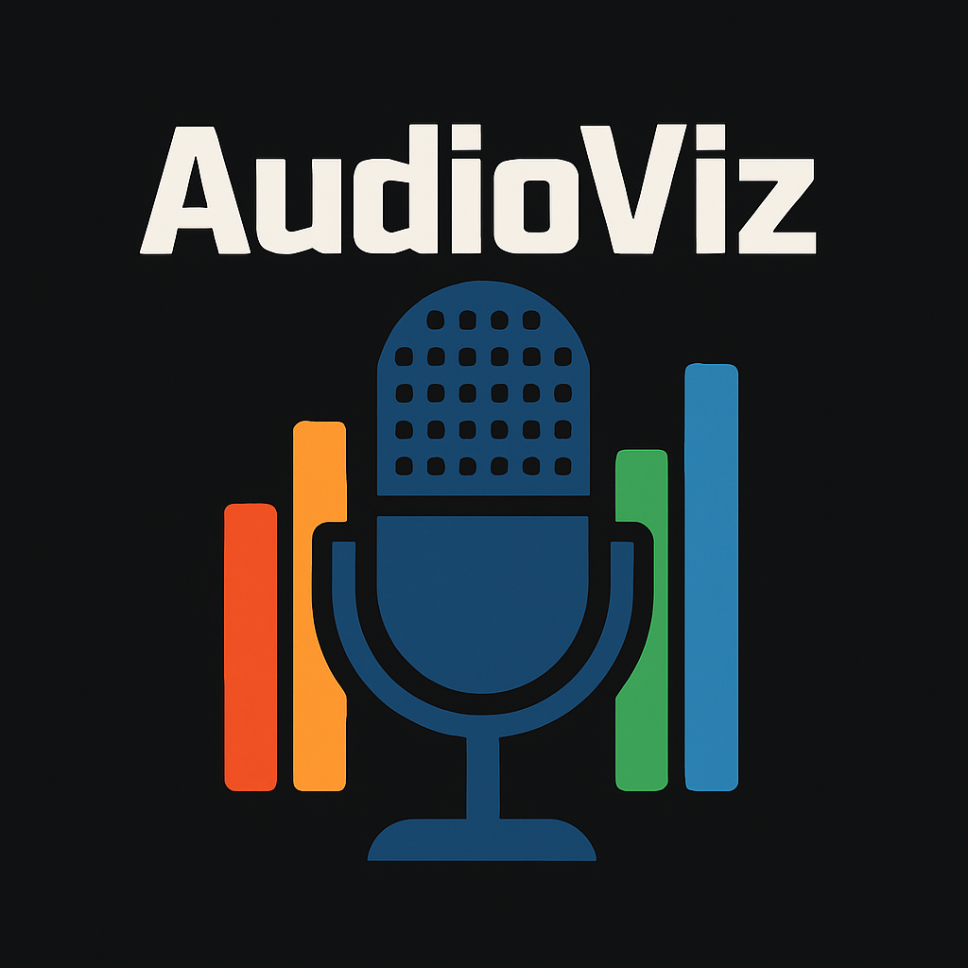 | AudioViz is an easy-to-use application for connecting your audio or live microphone to an LED display for visualizing your sound.  You can get started by opening the application and hooking up your LED display via USB through an Arduino.
The simple works: This application allows control over how the audio is displayed, giving you access to your input, color selection, audio mode, and allowing use of your own mp3 audio files.

Setup
Ensure you have properly downloaded the application and are able to run the program. Connect your Arduino to a USB port with your LED display connected. Choose the correct port and choose your desired method of audio input.
Note: May need more description on correct connections
Try it: Give your display a little test by selecting your microphone input under the Audio Device tab in the Audio Input menu (lower left), press Start in the Display Control Menu and give it a test by speaking.
Not showing? : If nothing is shown on your LED display, try this:
- First ensure that you have pressed Start on the Control Menu in the upper left.
- If no audio levels are displayed on the bar chart then the program does not detect any input, ensure you have the right input device selected.
- Check your USB port selection, make sure you have the right port selected.
- Ensure proper connection through the USB. Its possible the USB isn’t in properly.

App Menus
The AudioViz app has a few menus including the Display Control Menu, Audio Input, and the File Player. Here is how to use them:

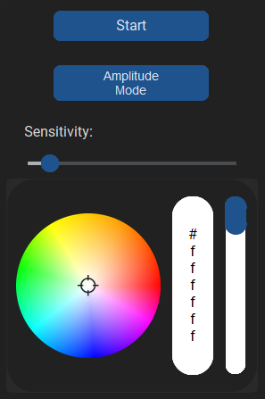
Display Control Menu
The Display Control Menu is where your main control for your display is. This menu contains a Start/Stop button, Audio Mode selection button, Sensitivity Slider, and a Color Picker. Each function changes your direct connection with your LED display. Note: The Start/Stop does not apply to the MP3 audio.

Audio Input Menu
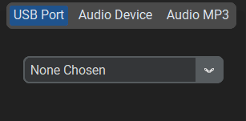
The Audio Input Menu is where you can change the method of audio input, giving you access to three tabs for different inputs. The USB Port tab allows you to select where your LED is hooked up. The Audio Device tab allows you to select what microphone/input device you would like to choose for live input. The Audio MP3 tab allows MP3 files to be used for your method of audio input.

MP3 File Player Menu
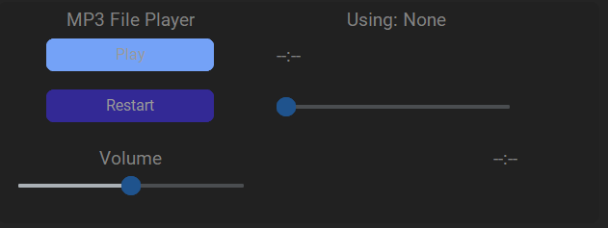
The MP3 File Player Menu is where you can use your selected MP3 file. To use an MP3 file go to the Audio Input Menu under the Audio MP3 tab, press the Select File button to import a MP3 file. The menu allows for simple control over your file.

Connection
Hardware required
- Arduino Uno
- 16×16 WS2812B LED matrix
- USB cable (USB-A to USB-B for Arduino Uno)
Wiring Instructions
- Connect the VCC pin on the LED matrix to the 5V from power supply
- Connect the GND pin on the LED matrix to the GND pin on the Arduino
- Connect the DATA IN pin of the LED matrix to digital pin 6 on the Arduino
USB Connection
- Plug the Arduino into your computer using the USB cable
- Inside the AudioViz app, go to the Audio Input menu → USB Port tab, and select the correct COM port for your Arduino.
Try it:
- Open the AudioViz Application
  - Launch the app and ensure it detects your Arduino. Go to the Audio Input menu, then the USB Port tab, and select the correct port
- Select an Audio Input
  - In the Audio Input menu, switch to the Audio Device tab and choose your microphone or desired input source
- Start the Visualization
  - In the Display Control Menu, press the Start button. Speak into your microphone
- Watch the LEDs React
  - If everything is set up correctly, your LED grid should now light up in columns and rows based if on frequency or amplitude mode

